## Custom Workflow using Visual Studio 2012 that Calls External Web Services

## Description:

This sample workflow demonstrates how to create a workflow using Visual Studio 2012 that calls an external Web service. By calling the service the workflow also makes use of the new DynamicValue data type.

The workflow is bound to a list called Customers. After the user enters a CustomerID, they can manually run the workflow. It searches for the customer based against the public Northwind sample OData service (<http://services.odata.org/Northwind/Northwind.svc/>). When it finds the customer it adds the details it retrieves from the service to the list item and concludes.

The part of the workflow that calls the web service and extracts the details from the response is contained within a custom activity, GetNWCustomerDetailsWorkflow.

## Prerequisites

1. Installed & configured SharePoint 2013 RTM environment that is connected to a configured Workflow Manager 1.0 farm
2. Service Bus 1.0 February 2013 Cumulative Update applied
3. Workflow Manager 1.0 February 2013 Cumulative Update applied
4. SharePoint 2013 March 2013 Public Update applied
5. Visual Studio 2012 RTM
6. Office Developer Tools for Visual Studio 2012 RTM

## Running the Sample - Instructions

* Launch Visual Studio 2012
* Open the solution in Visual Studio 2012:

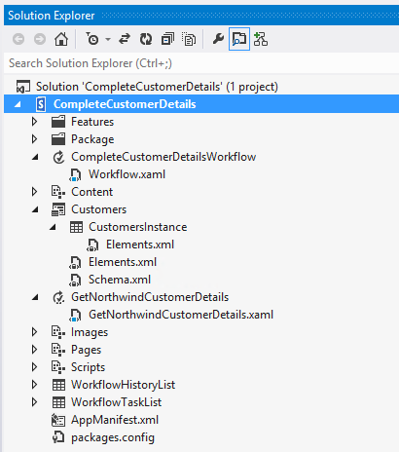

* In the Property tool window, edit the Site URL to point to the site you want to deploy it to.
* Press F5 to build & deploy the workflow
* Follow the instructions app homepage:

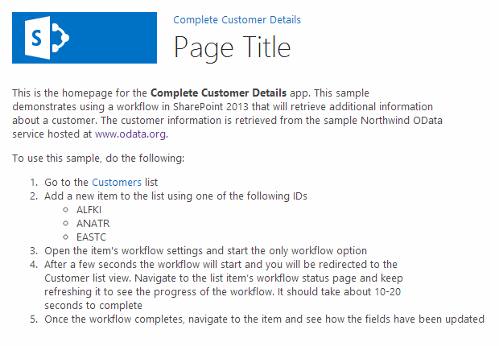

* When the browser opens, navigate to the Customers list and create a new customer item. Only enter the **CustomerID** field with the value **EASTC**:

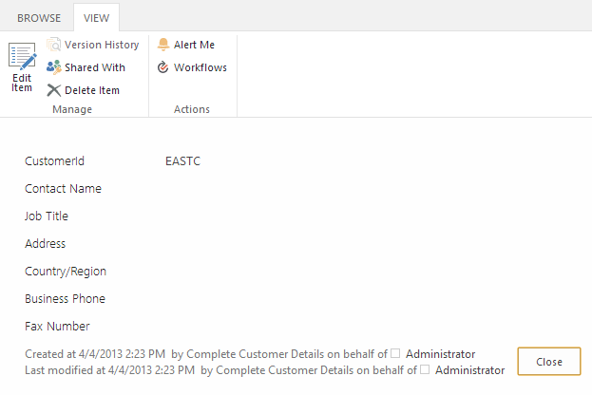

* After creating the item, go to the item and manually start the workflow:

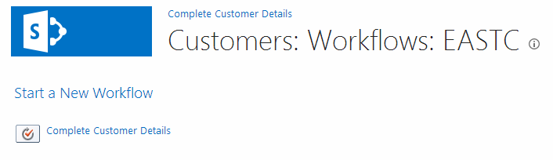

* After a few seconds the workflow will start and you will be redirected to the Customer list view. Navigate to the list item’s workflow status page and keep refreshing it to see the progress of the workflow. It should take about 10-20 seconds to complete:

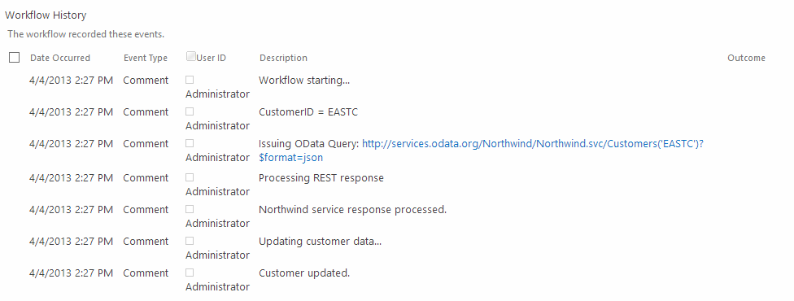

* Once the workflow is complete, navigate to the item and see how the fields have been updated:

